Senior Project

**House Hawk**

*Home Security Application*

**DEVELOPED BY**

|  |  |  |
| --- | --- | --- |
| Jake Caggese | Andrew Freitas | Matt Moore |
| Joshua DeNoble | Joe LaGrossa | Domenick Palmiotto |
|  | Ryan Lindsay |  |

**SCRUM MASTER**

Joshua DeNoble

**GITHUB LOCATION**

https://github.com/RyanLindsay48/CSSeniorProject

**SLACK WORKSPACE**

# seniorproject-4.slack.com

# Project Summary

The House Hawk system is designed to provide basic home monitoring to an end user. It utilizes a Raspberry Pi outfitted with two modules to record any necessary home security information. This information is then forwarded via a RESTful service and stored in a backend database system. Finally, the user is able to interact with a mobile phone application to view any potential home security problems sent from the Raspberry Pi.

# High Level Description

The Raspberry Pi (RPi) is outfitted with two attachments which enable it to determine if the home’s security is potentially compromised and take pictures if any suspicious activity is occuring. The first module is a passive infrared (PIR) sensor, which uses infrared radiation to determine if a warm body is moving in a specified radius. If a body is found in the field of view then the PIR sensor returns a signal to the RPi indicating that something is present. The second module is a camera based module, which takes pictures of the area every two seconds when the PIR sensor tell the RPi that something is present.

Images taken from the camera module are sent to a server instance located on Amazon Web Services (AWS) through a Flask-RESTPlus API. Image files themselves are sent to and stored on the server file system under a unique identifier for each user. During this time, the endpoint also stores the file path to each image into a database system. The database chosen for the House Hawk system is a MySQL database due to exceptional performance and scalability should the House Hawk system require expansion in the future.

Once images are stored on the server and links to the files created in the database, the mobile application can receive the images and notify the user. Images are retrieved from the server and sent to the mobile app through another endpoint located on the RESTPlus API system. The mobile app then sends a notification to the user indicating that their system has recorded images to view, and allows the user to view these images and decide if further action is required. If the user determines that no further action is required they can send a signal through a different endpoint which eventually makes it way back to the House Hawk system located in the user’s house, and notifies the system to reset.

# Problem Solving Approaches

Throughout the design process many different approaches were considered for various parts of the development process. Considerations include use of different information capturing systems, RESTful services, database systems, and mobile application development programs. This section of the report will walk through the different options that were considered during the design phase, and provide insight on why the current systems were chosen.

## Image Capturing System

Two image capturing systems were considered for use in the House Hawk system. Initially, a webcam based camera with motion sensor was considered during development, which allowed the system to be simplified by combining both the detection and capture systems together. However, after careful consideration a RPi based solution utilizing a sensor and camera module were chosen.

While the webcam based camera system allowed the image capturing to be simplified, it was determined that setting up one of these systems was much more expensive than the project allowed. Additionally, the webcam system would need to be completely replaced if the image capturing system was required to be replaced, or updated in the future (better resolution, increased functionality). The RPi based system on the other hand was relatively inexpensive and allowed the image capturing system as a whole to be broken into smaller components. This allows the system to be more expandable in the future, as only a certain module can be replaced instead of the image capturing system in its entirety.

## RESTful API Services

When looking at different frameworks to model the RESTful API services from two major contenders came to mind. Our first consideration was Django, the one of the most popular fully fletched out Python framework available. It consists of a full-featured Model-View-Controller framework, including a web-based IDE to develop in. Our second consideration was Flask, one of the most popular micro-frameworks available for Python. Because of its small size Flask does not include all the bells and whistles available in a full sized framework like Django. However, with the use of community extensions, Flask can be expanded to include Django-like capabilities.

Due to its small size and lower overhead, Flask was chosen for the House Hawk system. Because of its minimalistic approach, Flask has no built-in database services. However, with a community extension available the database system chosen could be easily incorporated into Flask, providing all the functionality required by the framework.

## Database System

For our database system we chose to use MySQL. This choice was made based on the team’s experience with database programming. MySQL is very well documented making it easy to learn and use compared to some of the less popular databases.

For our Database Model, we started simply. Our original model had entities for a User, the Raspberry Pi system, as well as the sensor and camera we’d be using.

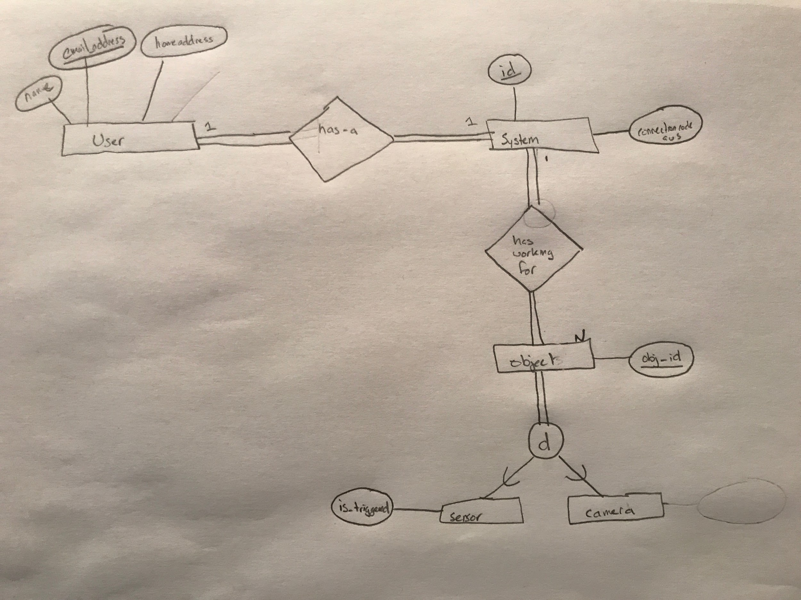

The next model we came up with was more detailed and built with growth in mind.

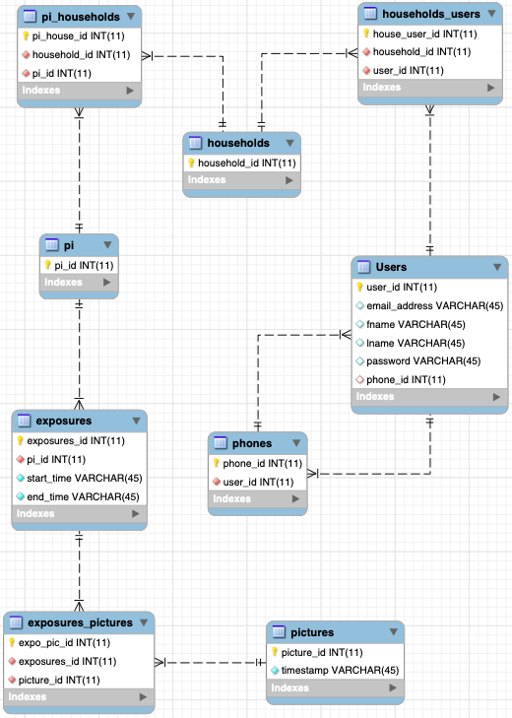

We kept the User and Pi tables, but added several columns on to the Users table that we thought might be necessary. We also got rid of the Sensor and Camera tables since we realized we don’t really need to store any information about them individually. Instead we added tables for Exposures and Pictures. An exposure can be described as a set (represented by a folder) of pictures taken between the time the sensor was activated and when either the user resets the system or enough pictures have been taken to meet the preset threshold. We also added the `households` table. Each household can have many pis and Users, though for our use case, pi’s can only belong to one Household at a time.

Our final model had a few alterations. We completely removed the `phones` table since our use case no longer required that we store any information about the user’s phone.

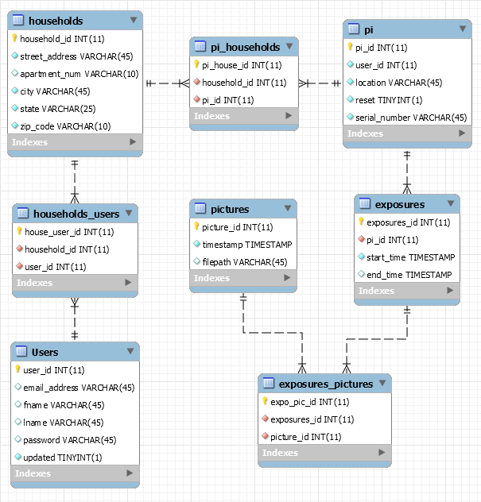

We also completed adding the necessary columns to households, pi, and pictures. For users we got rid of the phone_id column, since we no longer have that table, and added an “updated” column, which holds a single digit (in our case we’ll only change it to either 0 or 1) and that let’s the mobile application know whether or not a new row has been added to the exposure table, which then activates a notification being sent to the mobile app.

## Mobile Application OS

The mobile phone market is mainly ruled by two primary contenders at this time: Google’s Android, and Apple’s iOS. Both of these OS’s have different development platforms, and their own respective stores/markets. In order for House Hawk to have the largest marketing potential, it would be important to create mobile phone applications for both the Android and iOS systems. While this would typically mean developing an application on Android Studio (for Android) and creating a sister app on XCode (for iOS), a more recent development platform has been produced recently.

Flutter is an open-source mobile application development SDK developed by Google for use in development of mobile phone applications. This SDK allows for development in Android, iOS, as well as Google Fuchsia (an upcoming new OS). Because of its ability to reach all of the main mobile phone platforms, Flutter was chosen as our mobile OS development software of choice. This allows House Hawk mobile app development team to streamline their work, and develop the application once, instead of two times for two different operating systems.

**Table 1:** House Hawk Mobile Application Navigation Procedures

|  |  |  |
| --- | --- | --- |
| **INITIAL SCREEN** | **PROCEDURE** | **END SCREEN** |
| **Login Screen** | *Enter information & click login button* | *User’s Home Screen* |
| *Click new user button* | *Create Account Screen* |
| **Create Account Screen** | *Enter information & click create button* | *Login Screen* |
| *Click back button* | *Login Screen* |
| **User’s Home Screen** | *Click HouseHold Cameras Screen* | *HouseHold Cameras Screen* |
| *Click Most Recent Exposures* | *Most Recent Exposures*  *Screen* |
| *Click logout button* | *Login Screen* |
| **Account Info Screen** | *Click back button* | *User’s Home Screen* |
| **HouseHold Camera**  **Screen** | *Click on a certain camera* | *Pi Exposures Screen* |
| *Click the add camera button in the top right* | *Add Camera Screen* |
| *Click the back button* | *Home Screen* |
| **Add Camera Screen** | *Enter information & click Add Camera button* | *HouseHold Cameras*  *Screen* |
| *Click back button* | *HouseHold Cameras*  *Screen* |
| **Pi Exposures Screen**  **Screen** | *Click on any exposure button* | *Show Exposure Screen* |
| *Click back button* | *HouseHold Cameras*  *Screen* |
| **Show Exposures Screen** | *Click back button* | *Pi Exposures Screen* |
| **Most Recent Exposures**  **Screen** | *Click Refresh Button* | *Most Recent Exposures*  *Screen (Calls screen again*  *with updated picture list)* |
| *Click the back button* | *Home Screen* |

# App Screen Navigation

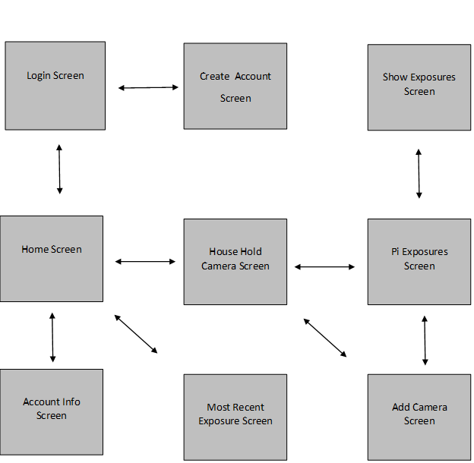

# Backend Information

There are two main backend components used in the House Hawk program, a mySQL database responsible for storing information and a RESTful API connecting to it. A schema was developed to show the relationships between database information stored on the tables. Fields and description of attributes for each table in the database can be seen in **Table 2**. In order to transfer information from the system to the database a RESTful API was developed. Multiple endpoints were created to handle the different types of information that would be passed between systems. A list of endpoints implemented can be located in **Table 3**.

**Table 2:** Description of Database Table Attributes

|  |  |  |
| --- | --- | --- |
| **TABLE** | **COLUMNS** | **DESCRIPTION** |
| **exposures** | *exposures_id*  *pi_id*  *start_time*  *end_time* | *Provides a grouping of pictures from a given time period taken from a specified camera (Pi) system* |
| **exposures_pictures\*** | *expo_pic_id*  *exposures_id*  *picture_id* | *Links pictures taken to a grouping of pictures given the picture and exposure IDs* |
| **households** | *household_id*  *street_address*  *apartment_num*  *city*  *state*  *zip_code* | *Provides each household with a unique ID* |
| **households_users\*** | *house_user_id*  *household_id*  *user_id* | *Links each user to a specified household given their user ID and associate household ID* |
| **pi** | *pi_id*  *user_id*  *location*  *reset*  *serial_number* | *Provides each Pi with a unique ID* |
| **pi_households\*** | *pi_house_id*  *household_id*  *pi_id* | *Links different camera (Pi) system to specified households given the Pi and household IDs* |
| **pictures** | *picture_id*  *timestamp*  *filepath* | *Provides pictures a unique ID and timestamp that the picture was taken* |
| **Users** | *user_id*  *Email_address*  *fname*  *lname*  *password*  *updated* | *Provides contact information such as name, email address. Describes the user’s account using their unique ID and password. Also determines which phone belongs to that user’s account* |

*Indicates a bridging table

**Table 3:** List of RESTful API Endpoints used

|  |  |  |  |
| --- | --- | --- | --- |
| **ENDPOINT** | **INPUT** | **OUTPUT** | **FUNCTIONALITY** |
| */upload* | *Image file* | */uploads/<filename>* | *Stores image to server path and URL* |
| */uploads/<filename>* | *---* | *Image file URL redirection* | *Displays stored image* |
| */api/user/login* | *Username & password* | *Navigation to selected page* | *Login to user account* |
| */api/user/login* | *Text for email* | *Json file of a user object from the database* | *Checks to see if the credentials entered by the user are valid.* |
| */api/user/household?user_id* | *user_id* | *Json file of a house associated to a user’s user_id* | *Used to save the user’s household information in global variables so the user can view their information on the Account Info Screen* |
| */api/user/updated* | *user_id* | *Returns the updated variable from the logged in user.* | *Used to see if the updated value in the logged in user has changed. If the updated variable in the database has changed that means that there are new exposures associated with a user.* |
| */api/user/updated/* | *User_id, ‘0’* | *PUT* | *Used to set the value of the of updated for the user back to 0 in the database.* |
| */api/user/account* | *Text for user information, username and password* | *Navigation to selected page* | *Takes data entered by user and stores it in the database.* |
| */api/users* | *None* | *List of all uses on the server* | *Used to return a list of users from the database. We compare the users entered email address to those already in the database to see if it is valid.* |
| */api/user* | *Users email address, password, firstname and lastname.* | *POST* | *Adds a user to the database* |
| */api/household* | *Users user_id, street address, city, state, and zip code. Apartment number is optional for this call. .* | *POST* | *Allows a user’s house to be added into the database.* |
| */api/exposure/recent* | *Returns a list of all of the images from the user’s most recent exposure.* | *user_id* | *Used to get all of the images from the user’s most recent exposure.* |
| */api/user/pis* | *Returns a list of all cameras associated with a user* | *user_id* | *Used to get all of the cameras associated to a user.* |
| */api/pi/exposures* | *Returns all of the exposures from a camera for a user* | *A json list of all of the exposures from a specific camera* | *Used to return a list of all of the exposures from a specific camera.* |
| *api/pi?user*  *_id* | *Takes a user_id, pi serial number and a location* | *POST* | *Allows the user to add another pi to their account.* |
| *api/pi/reset* | *Takes a pi_id and a reset value of 1* | *PUT* | *Allows the user to turn their camera off after they’ve determined that there is no intruder in their house.* |

# 

# App Screen Layouts

Although the House Hawk mobile application itself is not extremely complex, it still consists of different screens that allow the user to access their specific information. Since all information stored in the server is tied directly to the user’s account, a login screen allows users to insure that the mobile application is only displaying their information. User information is obtained from the login screen and then saved in global variables which are used to access that users information throughout the app.

The widgets made on the screens were primarily composed of text boxes, text form fields, buttons and images. The layouts used were both ListView and GridView layouts.

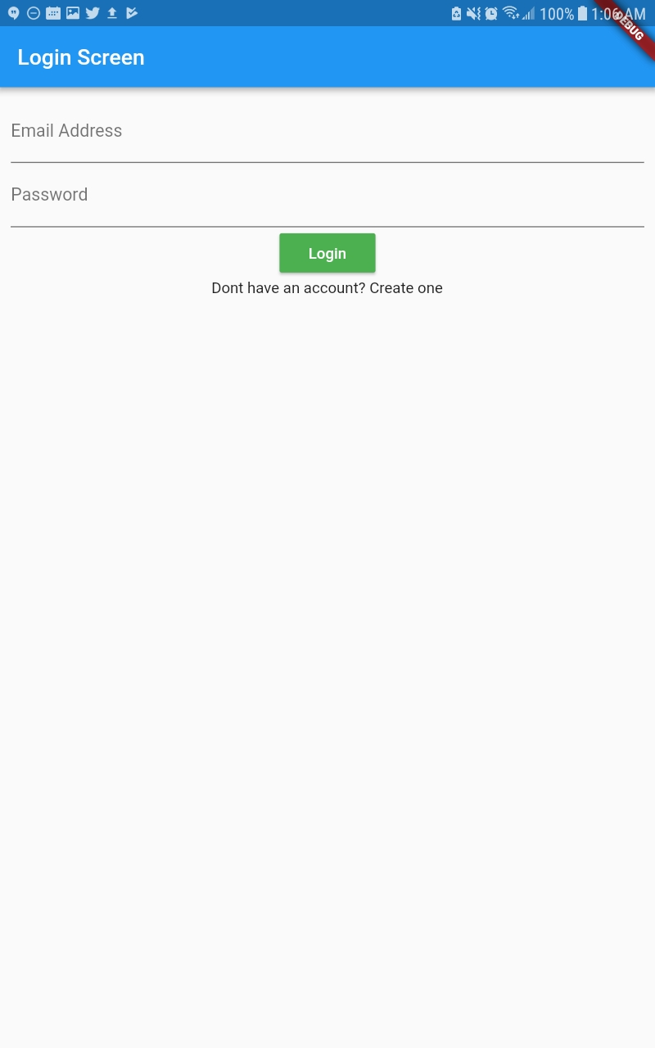 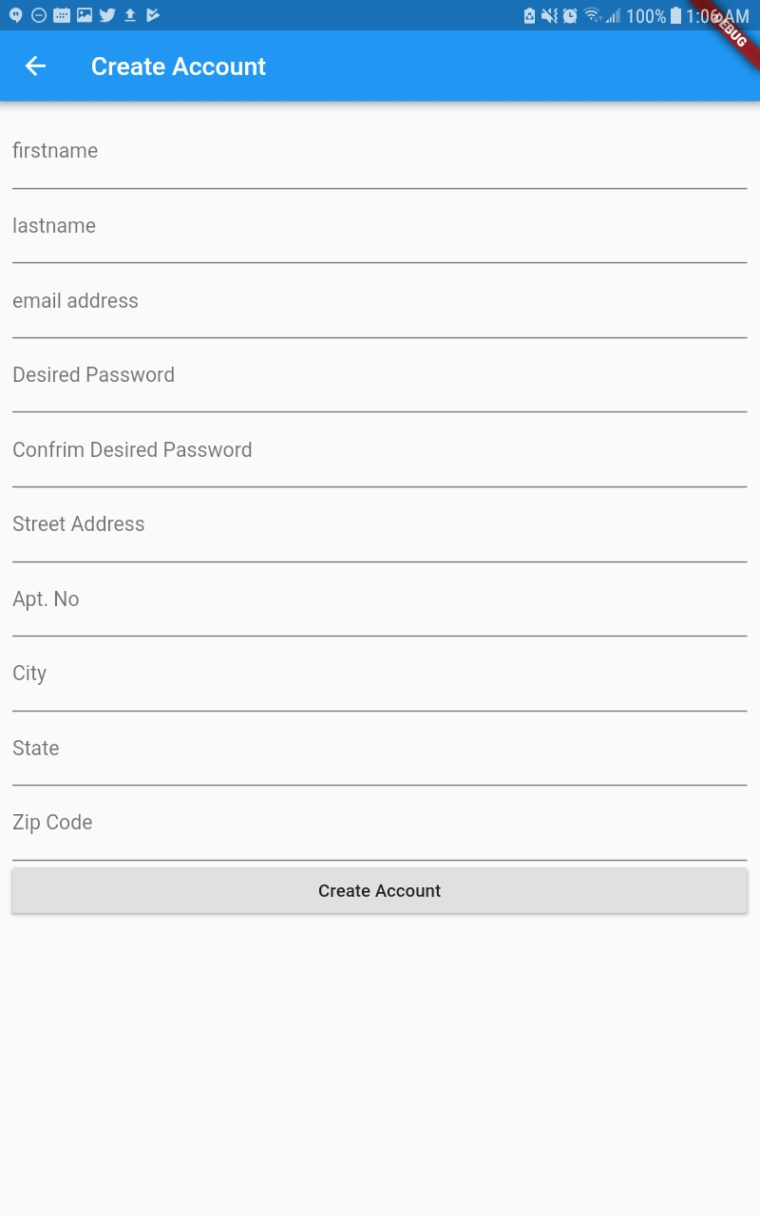 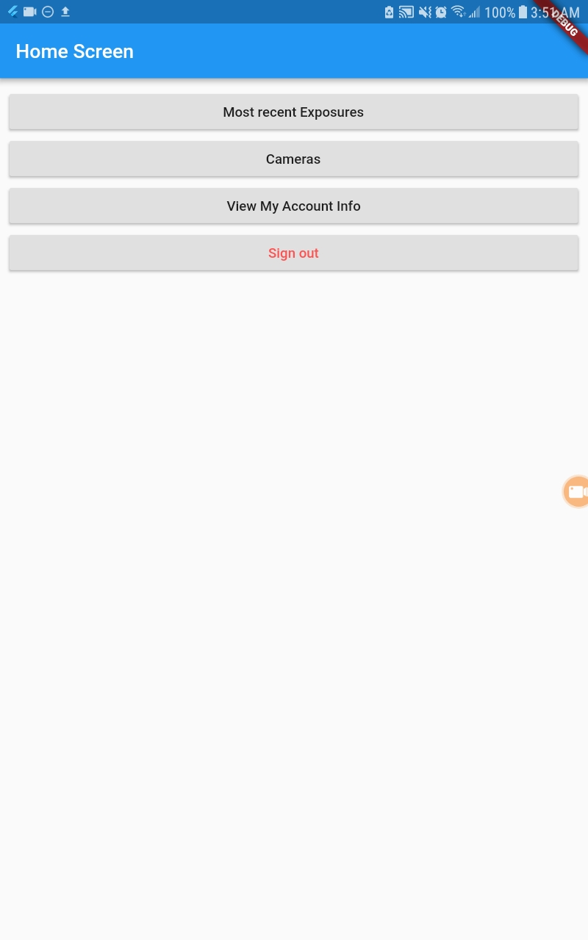

**Login Screen Create Account Home Screen**

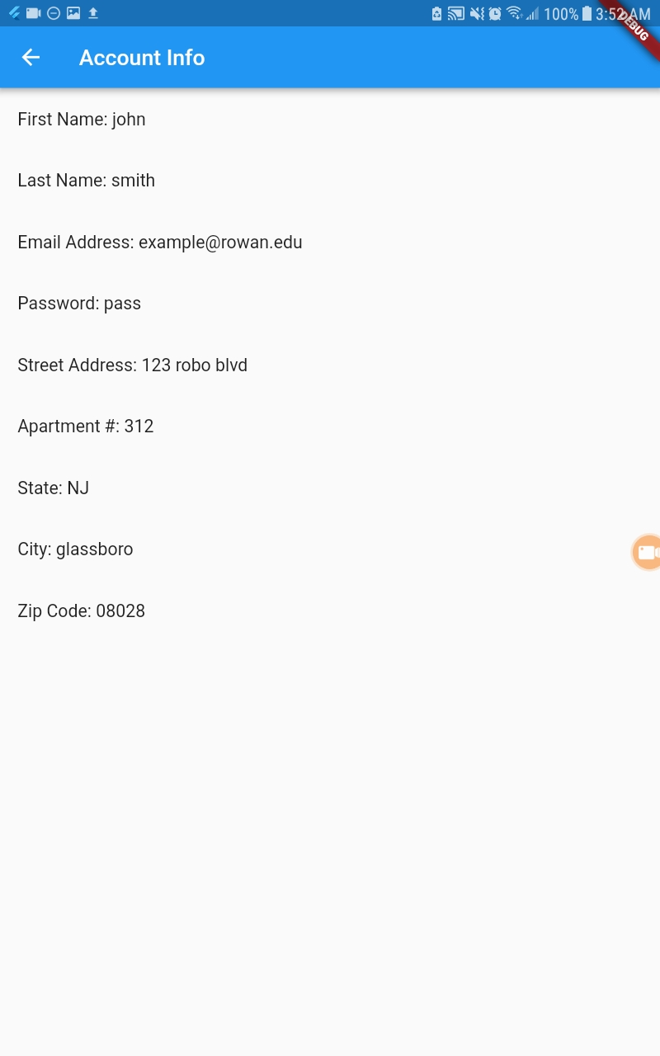 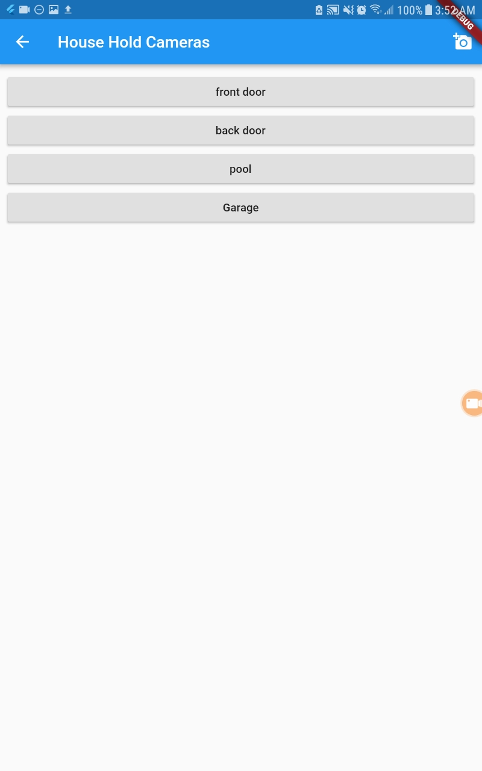 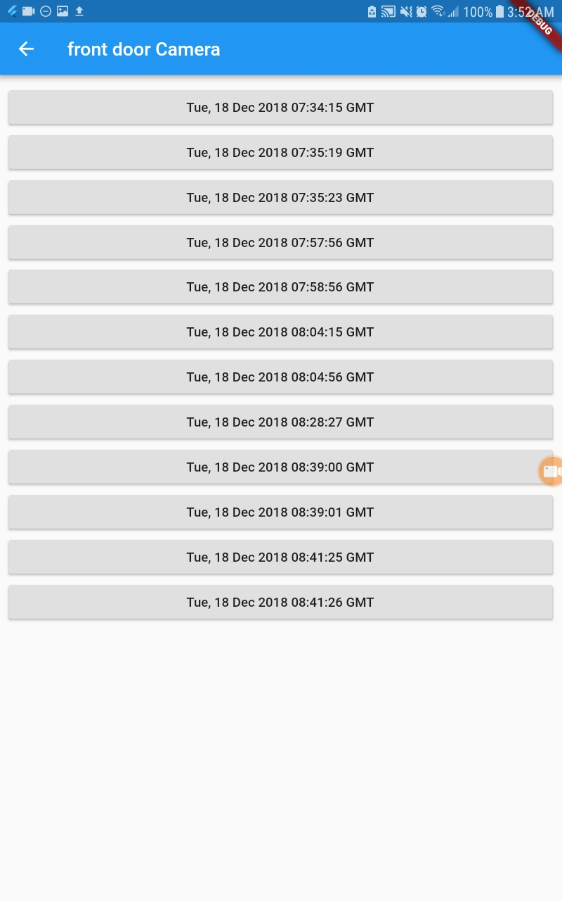

**Account Info Screen HouseHold Exposures Screen Pi Exposures Screen**

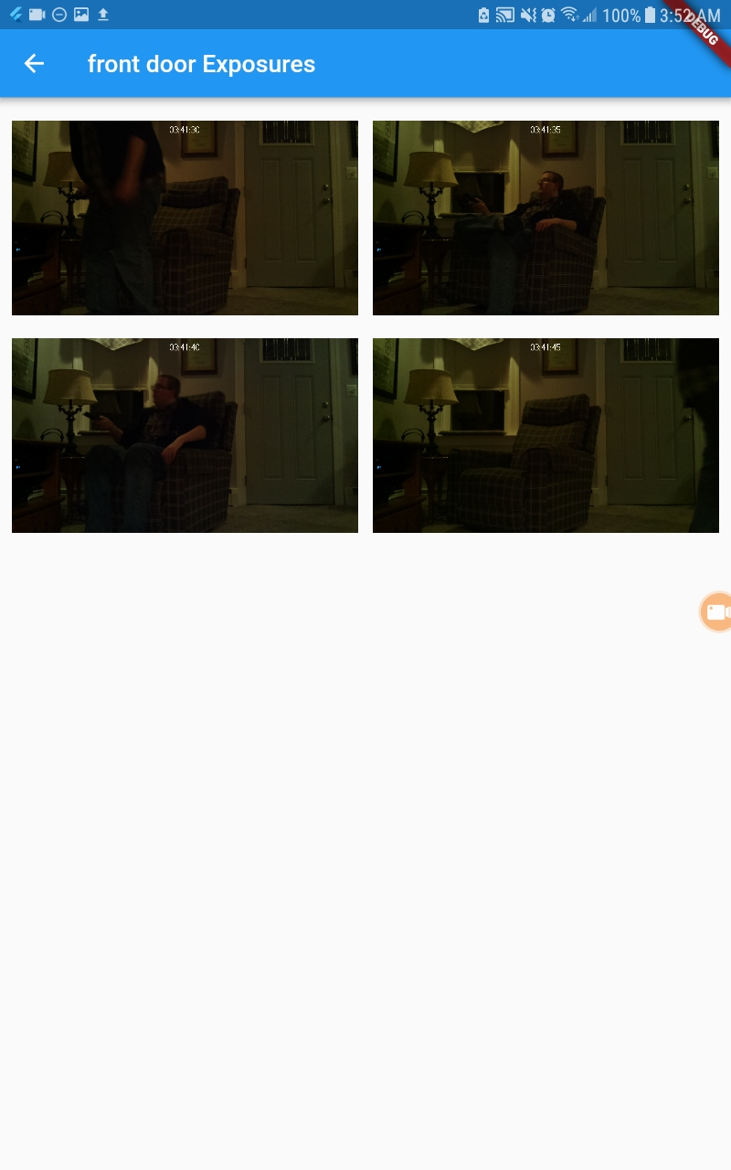 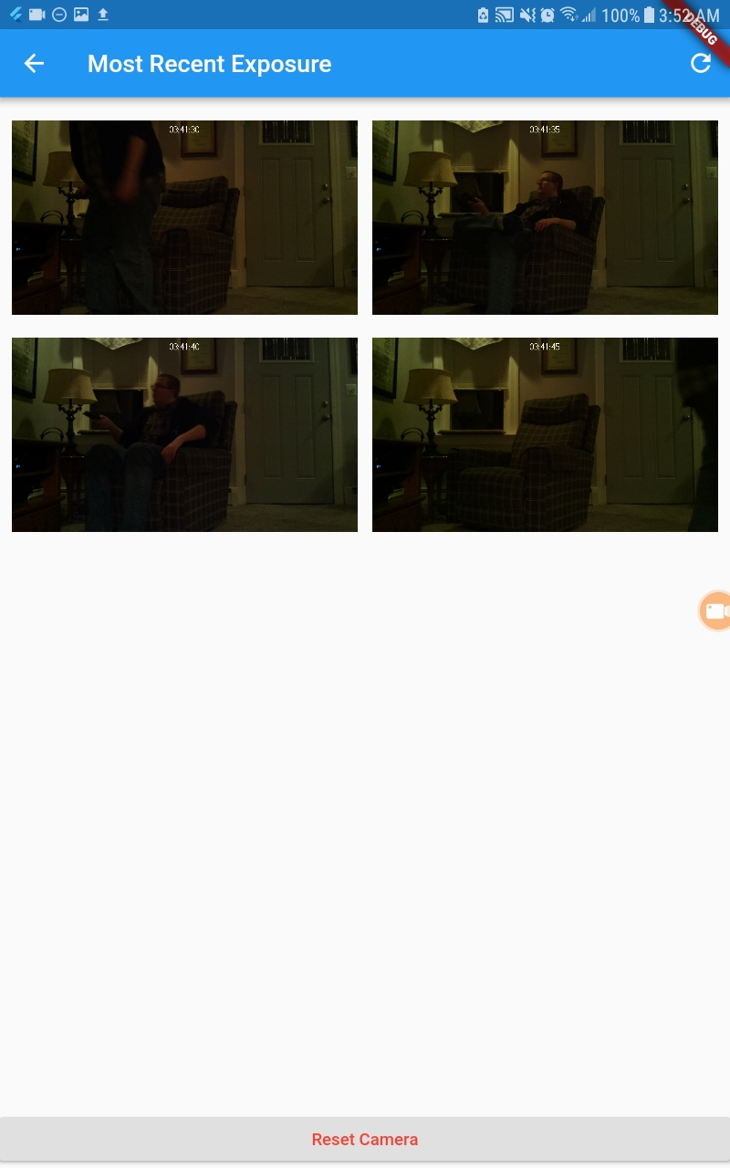 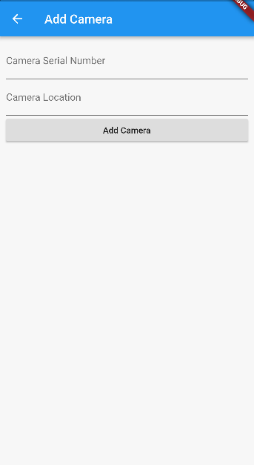

**Show Exposures Screen Most Recent Exposures Screen Add Camera Screen**

|  |  |
| --- | --- |
|  |  |
|  |  |
|  | |
|  | |

# App Screen Functionality

The House Hawk mobile application has nine screens associated with it: Login Screen, Create Account Screen, Home Screen, Account Info Screen, Most Recent Exposures Screen, HouseHold Camera Screen, Add Camera Screen, Pi Exposures Screen and Show Exposures Screen.

The Login Screen is used so the user can enter their username and password to login and access the app.Once the user presses the Login button on this screen they will be redirected to the User’s Home Screen. This page also has a link to allow the user to create an account. The Create Account button/link will redirect the user to the Create Account Screen.

The Create Account Screen allows the user to create an account for the House Hawk application. The user will be able to enter in their first name, last name, home address, email address, password, desired password, home address, apartment number(optional), city, state and zip code. If all of the information is entered in correctly and there isn’t a duplicate username our database a popup will appear that tells the user the account was created successfully. Upon closing the popup the user will be redirected to the Login Screen. If there is a similar username already in the database the user will be prompted to enter all of their information into the form again. There is also a back button that will redirect the user back to the Login Screen.

The User’s Home Screen page will display buttons for the user to view all of the HouseHold Cameras screen, the Most Recent Exposure Screen, their Account Information and a button to sign out.

The Account Info Screen shows all of the user’s information that they entered when signed up for the app. There is also a button to go back to the HomeScreen.

The Most Recent Exposures Screen Shows all of the images from the most recent exposure associated with a user. There is a button to refresh the screen since the screen can be accessed from pressing on the push notification. When a user clicks the push notification they will only see the images in the most recent exposure at that point in time. They would need to click the refresh button to see the images that were taken after the screen initially loaded. There is also a Reset Camera button that resets the camera associated to the most recent exposure.

The HouseHold Camera screen allows the user to view all of the cameras associated to their account. The cameras are seen as buttons and when a user clicks on one of the buttons it redirects the user to the PiExposures Screen. There is a back button to go back to the Home Screen and a camera button that when clicked redirects the user to the Add Camera Screen.

The Add Camera Screen allows a user to add a camera to their account. The user will be prompted to enter in the serial_id for their camera and the location of their camera. There is an Add Camera button that will add the camera to their account. There is also a back button that will redirect the user back to the HouseHold Camera Screen.

The Pi Exposures Screen shows all the exposures associated to a certain camera. Each exposure is marked via their TimeStamp. When a user clicks on an exposure they will be redirected to the Show Exposures Screen. There is also a back button that will redirect the user back to the HouseHold Camera Screen.

The Show Exposures Screen shows all of the pictures associated to a specific exposure. There is also a back button that will redirect the user back to the Pi Exposures Screen.

**TABLE 4:** List of Endpoints Used by Mobile Application

|  |  |  |  |  |
| --- | --- | --- | --- | --- |
| **APP SCREEN** | **ENDPOINT** | **INPUT** | **OUTPUT** | **Functionality** |
| *Login Screen* | */api/user/login* | *Text for email* | *Json file of a user object from the database* | *Checks to see if the credentials entered by the user are valid.* |
| *Login Screen* | */api/user/household?user_id* | *user_id* | *Json file of a house associated to a user’s user_id* | *Used to save the user’s household information in global variables so the user can view their information on the Account Info Screen* |
| *Login Screen* | */api/user/updated* | *user_id* | *Returns the updated variable from the logged in user.* | *Used to see if the updated value in the logged in user has changed. If the updated variable in the database has changed that means that there are new exposures associated with a user.* |
| *Login Screen* | */api/user/updated/* | *User_id, ‘0’* | *PUT* | *Used to set the value of the of updated for the user back to 0 in the database.* |
| *Create Account* | */api/user/account* | *Text for user information, username and password* | *Navigation to selected page* | *Takes data entered by user and stores it in the database.* |
| *Create Account* | */api/users* | *None* | *List of all uses on the server* | *Used to return a list of users from the database. We compare the users entered email address to those already in the database to see if it is valid.* |
| *Create Account* | */api/user* | *Users email address, password, firstname and lastname.* | *POST* | *Adds a user to the database* |
| *Create Account* | */api/household* | *Users user_id, street address, city, state, and zip code. Apartment number is optional for this call. .* | *POST* | *Allows a user’s house to be added into the database.* |
| *Home Screen,Most Recent Exposure Screen,*  *LoginScreen (used for push notifications)* | */api/exposure/recent* | *Returns a list of all of the images from the user’s most recent exposure.* | *user_id* | *Used to get all of the images from the user’s most recent exposure.* |
| *Home Screen* | */api/user/pis* | *Returns a list of all cameras associated with a user* | *user_id* | *Used to get all of the cameras associated to a user.* |
| *House HoldCamera Screen* | */api/pi/exposures* | *Returns all of the exposures from a camera for a user* | *A json list of all of the exposures from a specific camera* | *Used to return a list of all of the exposures from a specific camera.* |
| *Add Camera Screen* | *api/pi?user*  *_id* | *Takes a user_id, pi serial number and a location* | *POST* | *Allows the user to add another pi to their account.* |
| *Most Recent Exposure Screen* | *api/pi/reset* | *Takes a pi_id and a reset value of 1* | *PUT* | *Allows the user to turn their camera off after they’ve determined that there is no intruder in their house.* |
| *PiExposuresScreen* | *api/exposure/pictures* | *Takes an exposure_id* | *Returns a list of pictures from that specific exposure* | *Allows the user to get a list of pictures from a specific exposure* |

# User Authentication and Data Security Issues

In order to help ensure that users are only authorized to view their personal data, users require a unique identifier based on their account. This will be handled by creating a hashing algorithm to create a hash of the user’s username and ensuring that each hash is unique. For safety reasons we can also use this method on the user’s password, to further ensure account security.

Another data issue that could arise would be the security of user images. Because images can potentially be in a private setting (IE in the user’s house), it is important to ensure that the image files are kept in a secure manor. Therefore the files should be encrypted based on either a SHA or AES type encryption algorithm using a unique generated password.

# 

# Tech Stack

The House Hawk mobile application was designed using a Flutter plugin for the Android Studio mobile development application, which allows it to be run on Android, iOS and Fuchsia. No external/third-party APIs calls are made by the program. However, the RESTful API developed for the application is based on Python Flask microframework utilizing Nginx and Gunicorn. The RESTful service is located on an Ubuntu EC2 instance hosted by Amazon Web Service. This server is also running a mySQL database to handle storage of most app related data. Python scripts were developed for use in the Raspberry Pi system. The mobile application was programmed using Dart, which compiles into JavaScript.

# Mid-Assessment

For the mid-assessment we would like to have the majority of the project nearing completion. This includes having all endpoints setup on the RESTful service, having both the Raspberry Pi and mobile application able to connect to and send information over the endpoints, and finishing the mobile application. A list of tasks assigned to each member can be found below (**Table 5**).

**Table 5:** List of Tasks Assigned to Each Member

|  |  |  |
| --- | --- | --- |
|  | **TASK** | **TEAM MEMBER** |
| 1 | Finish setting up endpoints | Matt Moore, Ryan Lindsay |
| 2 | Connect RPi to appropriate endpoints | Ryan Lindsay, Joshua DeNoble |
| 3 | Connect app to appropriate endpoints | Andrew Freitas, Joe LaGrossa, Domenick Palmiotto |
| 4 | Connect endpoints to database | Domenick Palmiotto, Joshua DeNoble |
| 5 | Finish mobile app development | Andrew Freitas, Joe LaGrossa |
| 6 | Ensure security of user information | Jacob Caggese |